Customer Behaviour Analysis

Project Overview
This project analyzes customer purchasing behaviour from a company. The aim of this project is to discover what drives purchases, such as customer segments, age, shipping type, product preferences, age group, etc., to drive business decisions.

Dataset Summary
- Rows: 3900
- Columns: 18
- Key features:
  - Customer Demographics: Age, Gender, Location, Subscription Status
  - Purchase details: Items purchased, Category, Purchase amount, Season, Size, Colour
  - Shopping behaviour: Discount applied, Promo code used, Previous purchases, Frequency of purchases, Review rating, Shipping type
- Missing data: 37 values in the Review rating column

Exploratory Data Analysis in Python
  - Data loading: Imported the dataset into Python using pandas

- Initial Exploration: got summary statistics and structure of the dataset.

- Missing Data Handling: I found the columns with missing Data. The Review rating column had missing data. I used the median for each category to fill in null values.
- Naming Convention: I changed the naming convention for the column to snake casing, so that it would be easier to process with SQL

- Feature Engineering:
  - Created an age_group column, which assigned the various ages into categories to help with analysis
  - Converted the purchase_frequency to number_of_days between purchases to help with data processing
- Data Consistency check: discount_applied and promo_code_used seemed to be talking about the same thing, so after checking and seeing that both columns described the same thing, I dropped the promo_code_used column to remove redundancy.
- Database Integration: Connected Python script to PostgreSQL to perform further analysis

5. Data Analysis Using SQL (Business Transactions)
After the initial data exploration in python, I connected the data to SQL to answer key business questions. The SQL file can be found in the linked repository. These were teh questions asked and the answers:

- Revenue by Gender: Compared total revenue by male vs. female customers
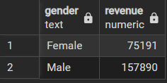

- High Spending Discount: Identified customers who used a discount but still spent higher than the average amount
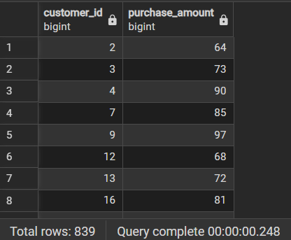

- Top 5 Products by Rating: Found products with the highest average review ratings
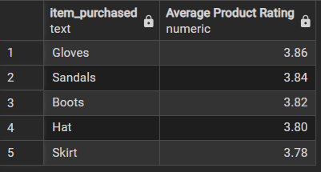

- Shipping Type Comparison: Compared average purchase amounts between standard and express shipping
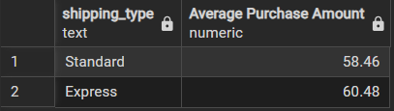

- Subscribers vs. Non-Subscribers: Compared average spend and total revenue across subscription status
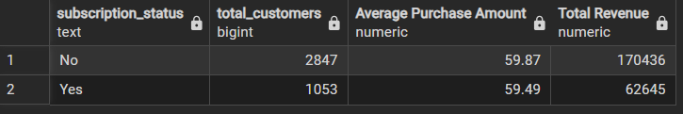

- Discount-Dependent Products: Identified 5 products with the highest percentage of discounted purchases
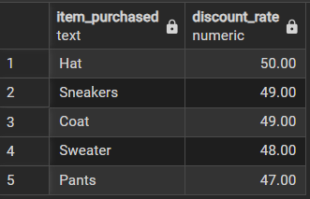

- Customer Segementation: Classified numbers into New, Returning, and Loyal segments based on purchase history
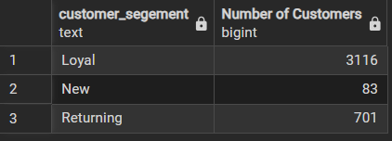

- Top 3 Products per Category: Listed the three most purchased products within each category
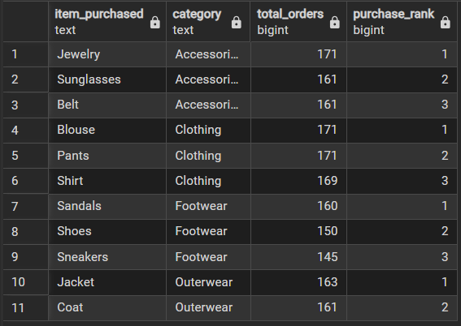

- Repeat Buyers and Subscribers: Checked whether customers with greater than 5 purchases are more likely to subscribe
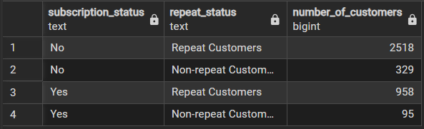

- Revenue by Age group: Calculated the total amount of revenue generated by each age group
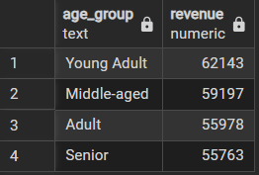

6. Power BI dashboard
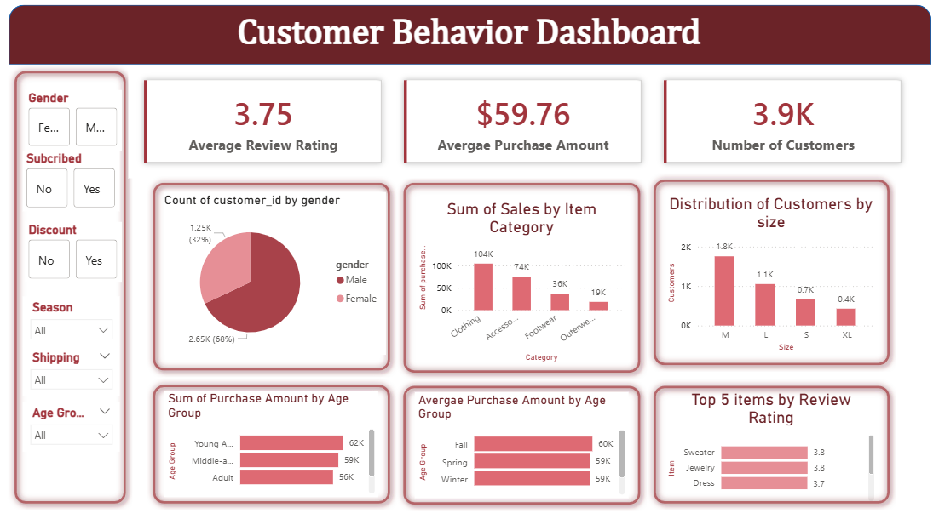

7. Insights

- The store has a lot more male customers with approximately 70% of the customers being male
- Of all the categories sold, clothing items sell the most
- Young adults and Middle age people contribute more to the store’s revenue
- The store sells more spring items with spring being the only season that generates over $60k in revenue
- More than 75% of the store’s customers are loyal customers so the store must be doing something good to keep customers coming back
- The store has a lot of non subscribers
- Repeat customers are equally as likely as non repeat customers to subscribe

8. Business Recommendations
- Boost subscription: The store has a lot more non-subscribers than subscribers so they can work on boosting subscription only benefits to make more people subscribe
- Loyalty program: The store already has a lot of loyal customers however with the addition of loyalty programs, they can push the new and returning customers to shop at the store more often therefore boosting revenue
- Targeted Marketing: Focus marketing on middle age and young adult customers as well as male customers because they generate the most revenue
- Smart inventory: Stock up on medium size items then large, small and XL to reduce unused inventory as well as prevent selling out on medium sized items
- Product positioning: The store could highligh the highest rated and top selling products in campaigns
- Seasonal Promotions: Have a lot of promotions during the spring season as it generates more revenue. Also creating new spring lines to drive revenue even further

